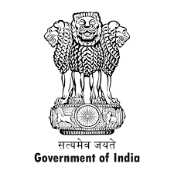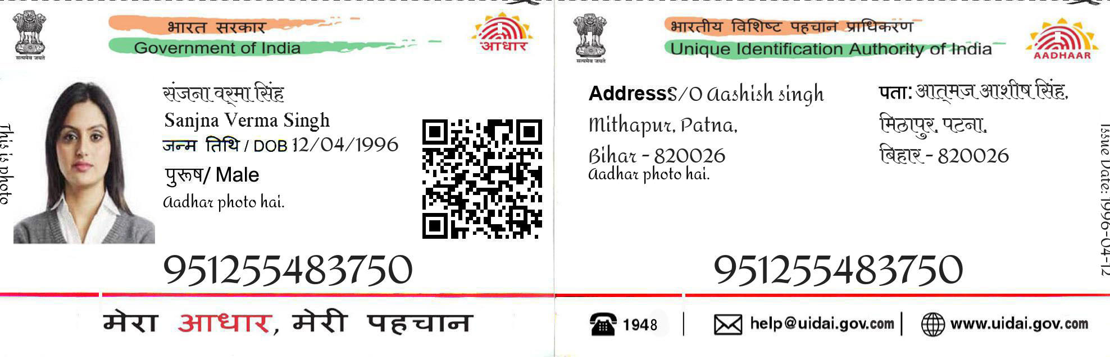

1234 6543 8765

Address/Narmadajha

Bijwasan delhi

Bihar-847525

1234 6543 8765

Narmada Jha

DOB/26/04/2004

Female/